**CIP-Napier Data Loading/Extraction Tech Specification Document**

Contents

Introduction 2

Purpose and Scope 2

Data Flow Process 2

CIP-Napier Env: 3

Source System Objects (Tables) used for Napier 4

Target Database (TMS5_Napier) Objects 5

SSIS Packages 7

ETL Scheduling 7

Napier SQL Server Jobs: 7

1. TMS5_Napier_DailyDataLoad (Occurs every day at 3:30:00 AM.): 8

Step 1: TMS5_Napier Data Refresh: 8

Step 2: SSIS_SQLtoCSV Data Loading (non-trans) 9

Step 3: If Job Success – Mail To: 9

Step 4: If Job Fails – Mail To 9

2. TMS5_Napier_DailyDataLoadTrans (Occurs every day at 4:15:00 AM): 10

Step 1: Generation of CSV files for transactions. 10

Step 2: If Job Success – Mail To 10

Step 3: If Job Fails– Mail To 10

ETL Job Run Log Table 10

Bitbucket Repository 10

FAQ 11

# Introduction

The purpose of this document is to provide information about data extraction details from different data sources, loading into the Target database (TMS5_Napier) and creating CSV files for further processing by Napier.

# Purpose and Scope

The purpose of this document is to

1. Outline the details of the design data flow process for Napier platform.
2. Napier database and ETL structure details.

b. Data Extraction, ETL and Job Monitoring details.

c. Notifications of the Job Success/failures

# Data Flow Process

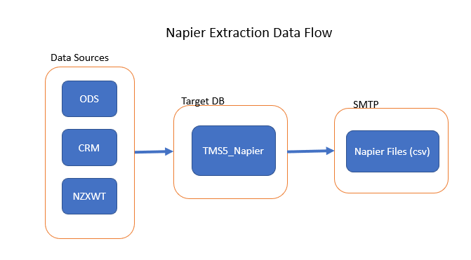

**Source Layer:** The data is extracted from the individual source systems and would be consolidated into the Napier Database (TMS5_Napier). Only the tables and the columns which participate in the Napier system would be extracted on a periodic basis.

**Target DB:** Stores data from the source systems for further processing. In this layer, data delivered from the sources staging will undergo data standardization, Data cleansing, Validation and Transformation (based on the requirement) before transferring to SMTP.

**SMTP:** The ETL process will generate csv files from the TMS5_Napier database and transport them to a shared SMTP path for further processing by Napier.

**Logging and Exception Handling –**

As part of the ETL process, all data extraction and loading processes will be identified and recorded in a table called '[ETL].[BatchLog]'. It has been implemented on every layer.

**[ETL].[BatchLog]**

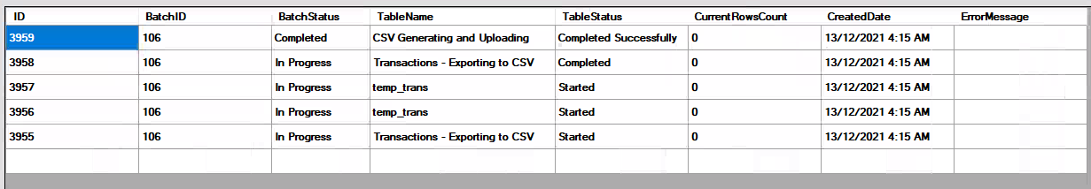

# CIP-Napier Env:

Production Server: SVSQLCIP\SQLCIP

Database Name: TMS5_Napier

|  |  |  |  |
| --- | --- | --- | --- |
| **Source Database (Linked Server)** | **Target Database** | **SMTP Path** | **Comments** |
| Source Server: TGASQLENT01\BI  Source Database: ODS | Server: SVSQLCIP\SQLCIP  Database: TMS5_Napier | \\SVSFTP2K8001\napier\PRD | Linked Server?  Used ‘**SQL_BI**’ Linked Server to connect to Source System from ‘SVSQLCIP\SQLCIP’ Server to extract data. |
| Source Server: KAPSQLCRM\CRM  Source Database: CRM_MSCRM | Linked Server?  Used ‘**Dynamic’** Linked Server to connect to the CRM Prod Source system from ‘SVSQLCIP\SQLCIP’ Server to extract data. |
| Source Server (SSAS): tgasqlent01\bi_as_tab  Source Database: ‘CIP Tabular Model’ | Linked Server?  Used **‘TabularModel**’ Linked Server to connect to the SSAS Prod Source system from ‘SVSQLCIP\SQLCIP’ Server to extract data. |
| Source Server:  cip-sql-reporting.nzxwt.nz  Source Database: CRAIGS_PROD_Main | Linked Server?  Used ‘**NZXWTrptsrv’** Linked Server to connect to the NZXWT Prod Source system from ‘SVSQLCIP\SQLCIP’ Server to extract data. |

# Source System Objects (Tables) used for Napier

|  |  |
| --- | --- |
| **Source System** | **Tables used as sources** |
| ODS | * ODS.[CRM_Dynamics].[Account] * [ODS].[CRM_Dynamics].[dsl_roles] * [ODS].[CRM_Dynamics].[Contact] * [ODS].[Chelmer_ACE].[StClients_Master] * [ODS].[CRM_Dynamics].[StringMap] * [ODS].[CRM_Dynamics].[dsl_portfolioservice] * [ODS].[CRM_Dynamics].[dsl_portfolioservicelevel] * [ODS].[CRM_Dynamics].[dsl_country] * [ODS].[CRM_Dynamics].[dsl_advisercommissioncode] * [ODS].[CRM_Dynamics].[BusinessUnit]   --Transactions   * ODS.Wrapport.Trn * ODS.Wrapport.Portfolio * ODS.Wrapport.Drum * ODS.Wrapport.Glt * ODS.Wrapport.DataProvider * ODS.Wrapport.Currency * ODS.Wrapport.Asset * ODS.Wrapport.Exchange * ODS.Chelmer_ACE.EqContracts * ODS.Chelmer_ACE.EqOrders   --NZXWT Tran   * ods.NZXWT.CoreTransactionExtract |
| PROD – ‘CIP Tabular Model’ | * 'Account Holdings Monthly' * 'Asset' * 'Account Holdings Date' * ‘Account’ |
| CRM | * [CRM_MSCRM].[dbo].[Contact] (few fields) * [CRM_MSCRM].[dbo].SystemUser * [CRM_MSCRM].[dbo].dsl_natureandpurposeofbusiness * [CRM_MSCRM].[dbo].dsl_dsl_natureandpurposeofbusiness_account * [CRM_MSCRM].[dbo].dsl_identificationitem |
| NZXWT | * [CRAIGS_PROD_Main].dbo.CurrencyRate * [CRAIGS_PROD_Main].dbo.Currency * [CRAIGS_PROD_Main].dbo.ProductPrice * [CRAIGS_PROD_Main].dbo.Asset * [CRAIGS_PROD_Main].dbo.Portfolio * [CRAIGS_PROD_Main].dbo.PortfolioAssetHolding * [CRAIGS_PROD_Main].dbo.Asset * [CRAIGS_PROD_Main].dbo.PortfolioCashHolding * [CRAIGS_PROD_Main].dbo.ServiceDm |

# Target Database (TMS5_Napier) Objects

|  |  |  |
| --- | --- | --- |
| **Target System** | **Object Type** |  |
| TMS5_Napier | Tables | * [dbo].Accounts * [dbo]. LegalEntities * [dbo].Persons * [dbo].Roles * [dbo].Transactions * [dbo].Staging_Transactions (*Staging/Incremental data*)   **Ref (Master data datables)**   * [dbo].[Ref_ProductNames] * [dbo].[Ref_ProductsMap(CRMvsNapier)] * [dbo].[Ref_SecurityCodes]   **SSIS/ETL Config table**   * ETL.BatchLog (ETL Log details) * [ETL].[TableLoadStatus] * [ETL].[SSIS_Packages_Config] |
| Procs | **usp_PopulateSourceData(main)**   * [dbo].[usp_Populating_TempTables] * [dbo].[usp_Populating_Accounts] * [dbo].[usp_Populating_LegalEntities] * [dbo].[usp_Populating_Persons] * [dbo].[usp_Populating_Roles] * [dbo].[usp_Populating_Staging_Transactions] * [dbo].[usp_Populating_Transactions] * [ETL].[usp_BatchLog] * usp_sp_send_dbmail_Success * usp_sp_send_dbmail_Success_Trans * usp_sp_send_dbmail_Fail |
| Views | **Views for generating CSV files**   * [dbo].vwAccounts * [dbo].vwLegalEntities * [dbo].vwPersons * [dbo].vwRoles * [dbo].vwTransactions   **View used in ETL Package to generate CSV files**   * ETL.vwSSIS_Packages_Config   **Master Ref view (ProductCodes)**   * [dbo].vw_CRM_vs_Napier(ProductCodes) |

# SSIS Packages

|  |  |  |
| --- | --- | --- |
| **ETL/SSIS Packages** | **SSIS Package Name** | **Path (Prod Server: )** |
| SSIS Packages | TMS5_Napier_DailyDataLoad | To Refresh Target database and export **non-trans** data (csv file format) to SMTP shared path.  \\Svsqlcip\ssis\Napier\TMS5Napier_SourcetoCSVExport_Cust.dtsx |
| TMS5_Napier_DailyDataLoadTrans | To export **trans** data (csv file format) to SMTP shared path.  \\Svsqlcip\ssis\Napier\TMS5Napier_SourcetoCSVExport_trans.dtsx |

# ETL Scheduling

Scheduling is the process of automatically running the ETL process at a fixed time. The Scheduling of the Napier SSIS Package for ETL is done by Jobs in the SQL Server Agent. Dependency would be set between the steps so that one step executes only on successful execution of its predecessor. The job will be scheduled to run daily at a fixed time.

# Napier SQL Server Jobs:

Loading and transferring data from the source system to TMS5_Napier was done by running a SQL Server Job named **'TMS5_Napier_DailyDataLoad**'. Upon successfully refreshing data into the Target database TMS5_Database, it will extract data from the source tables and generate files that will be placed into the shared SMTP folder.

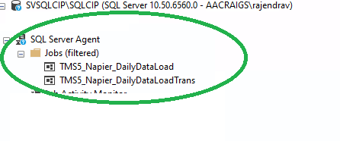

## TMS5_Napier_DailyDataLoad (Occurs every day at 3:30:00 AM.):

This is the main Napier Job which triggers daily at 3.30 AM and extract full data for **‘Accounts’, ‘Legal Entities’,’Persons**’ and Incremental refresh for ‘**Transactions’ .** it also generates the CSV files for ‘non-trans’ tables.



### Step 1: TMS5_Napier Data Refresh:

Following is the procedure that Job executes in the first step in order to refresh the target database:

|  |
| --- |
| USE [TMS5_Napier]  GO  DECLARE @return_value int  EXEC @return_value = [dbo].[usp_PopulateSourceData(main)]  SELECT ''Return Value'' = @return_value  GO |

1. ***Main Procedure: [dbo].[usp_PopulateSourceData(main)] :***

This Procedure consists of sub/nested Procedures that perform data transformation for Accounts, Persons, Legal Entities, and Transactions. The data is extracted through Linked Servers, which are already existing in the Production server and have connectivity with the source systems.

* 1. EXEC [dbo].[usp_Populating_TempTables] @lcBatchId=@lcBatchID

The procedure prepopulates data from source systems and loads it into temporary tables for further processing. Linked Server issues may occur at this point.

* 1. EXEC [dbo].[usp_Populating_Accounts] @lcBatchId=@lcBatchID

Full data refresh for Accounts

* 1. EXEC [dbo].[usp_Populating_LegalEntities] @lcBatchId=@lcBatchID

Full data refresh for Legal Entities

* 1. EXEC [dbo].[usp_Populating_Persons] @lcBatchId=@lcBatchID

Full data refresh for Persons

* 1. EXEC [dbo].[usp_Populating_Roles] @lcBatchId=@lcBatchID

Full data refresh (Bridge table) for Roles

* 1. EXEC [dbo].[usp_Populating_Staging_Transactions] @lcBatchId=@lcBatchID

Incremental data refresh for Transactions (Staging table)

* 1. EXEC [dbo].[usp_Populating_Transactions] @lcBatchId=@lcBatchID

Incremental data refresh (Transactions)

### Step 2: SSIS_SQLtoCSV Data Loading (non-trans)

Once the data has been loaded into the TMS5_Napier database successfully, this step will generate csv files for non-trans tables.

To generate the CSV files, it runs the following SSIS Package which can be found in the CIP Prod Server (SVSQLCIP/SQLCIP).

|  |
| --- |
| I:\Packages\Napier\TMS5Napier_SourcetoCSVExport.dtsx |

### Step 3: If Job Success – Mail To:

Upon successful completion of Data Refresh and csv files generation, it will trigger the success mail notification to the Business (to Compliance@craigsip.com).

### Step 4: If Job Fails – Mail To

If Job fails and it reports to ‘Mohan.vulchi@craigsip.com;matthew.andrews@craigsip.com;rajendra.vechalapu@craigsip.com;datateam@craigsip.com;Compliance@craigsip.com’

## TMS5_Napier_DailyDataLoadTrans (Occurs every day at 4:15:00 AM):

The job runs every morning at 4.15 am and generates csv files of incremental transactions.

### Step 1: Generation of CSV files for transactions.

I:\Packages\Napier\TMS5Napier_SourcetoCSVExportTrans.dtsx

### Step 2: If Job Success – Mail To

Notification to (Compliance@craigsip.com)

### Step 3: If Job Fails– Mail To

Notification to

(‘Mohan.vulchi@craigsip.com;matthew.andrews@craigsip.com;rajendra.vechalapu@craigsip.com;datateam@craigsip.com;Compliance@craigsip.com’)

# ETL Job Run Log Table

[ETL].[BatchLog] : Log details for ETL are recorded in this table, as well as any exception details.

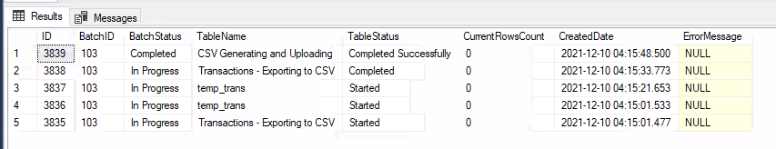

# Bitbucket Repository

(TMS5_Napier Database and SSIS Solution)

[craigsip.napier — Bitbucket](https://bitbucket.org/vrsanaidu/craigsip.napier/src/master/)

# FAQ

1. Common error with Linked Server: . Error: TCP Provider: An existing connection was forcibly closed by the remote host

This error can happen if source systems are not accessible or Linked Server is broken with high throttling error.

Fix: It is an intermittent issue and rarely happens. Upon business approval, please re-run the below two jobs at the time specified by Business

1. TMS5_Napier_DailyDataLoad
2. TMS5_Napier_DailyDataLoadTrans
3. ETL Job loads seven days' worth of Trans data every day at a specific time, then checks the Target Database for incremental data load (new data). Where can we change the criteria for loading previous days' Transaction data (if we need to change it for more than 7 days)?

Go to Proc: usp_Populating_TempTables

Changes to the below date criteria according to Business.

**Change** 1 : Wrapport Trans Table ->**t.postedDate** Filter

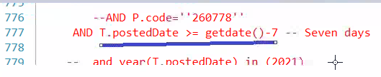

Change 2: NZXWT Trans Table -> t.MarketDate **filter**

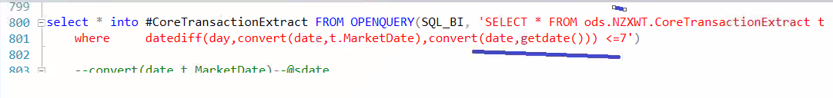

1. What is the name of the Master/Ref table that contains the product names to modify/add?

[dbo].[Ref_ProductNames]

1. What is the name of Master/Ref table that holds the CRM vs Napier Products Code mapping modify/add?

[dbo].[Ref_ProductsMap(CRMvsNapier)]

1. What is the name of the Master/Ref table that contains the security names modify/add?

[dbo].Ref_SecurityCodes

1. Which table holds details of daily ETL jobs and any errors?

[ETL].[BatchLog]

1. Which table contains the path location of the CSV files and the SQL query that generates the CSV files to modify?

[ETL].[SSIS_Packages_Config]

1. What table contains the flag that enables/disables CSV file generation?

[ETL].[TableLoadStatus]